|  | **BAHRIA UNIVERSITY, (Karachi Campus)**  *Department of Software Engineering*  **Assignment 1 - Fall 2022** |  |
| --- | --- | --- |

COURSE TITLE: **INTRODUCTION TO PSYCHOLOGY** COURSE CODE: **PSY-102**

Class: **BSE-V & III** Shift: **Morning**

Course Instructor: **Marvi Makhdoom** Time Allowed:  **2 Weeks**

Submission Date: 3rd NOV, 2022 Max. Marks: **5 Marks**

Name: **Muhammad Shoaib Akhter Qadri**

Enrollment No: **02-131212-009**

Regstration No: **79290**

**Question No. 1 [CLO1: 5 Marks]**

Students are requested to write about the psychological theory/perspective or school of thought that they think best define human behavior or mind. You should come up with the evidences, real life examples or past researches to back up your claim/s. (Min 200- 400 words)

**Answer:**

**Biological Perspective:**

There are many different ways of thinking about topics in psychology. The biological perspective is **a way of looking at psychological issues by studying the physical basis for animal and human behavior**. It is one of the major perspectives in psychology and involves such things as studying the brain, immune system, nervous system, and genetics.

* **Importance of nature:**

One of the major debates in psychology has long centered over the relative contributions of nature versus nurture. Those who take up the nurture side of the debate suggest that it is the environment that plays the greatest role in shaping behavior. The biological perspective tends to stress the importance of nature.

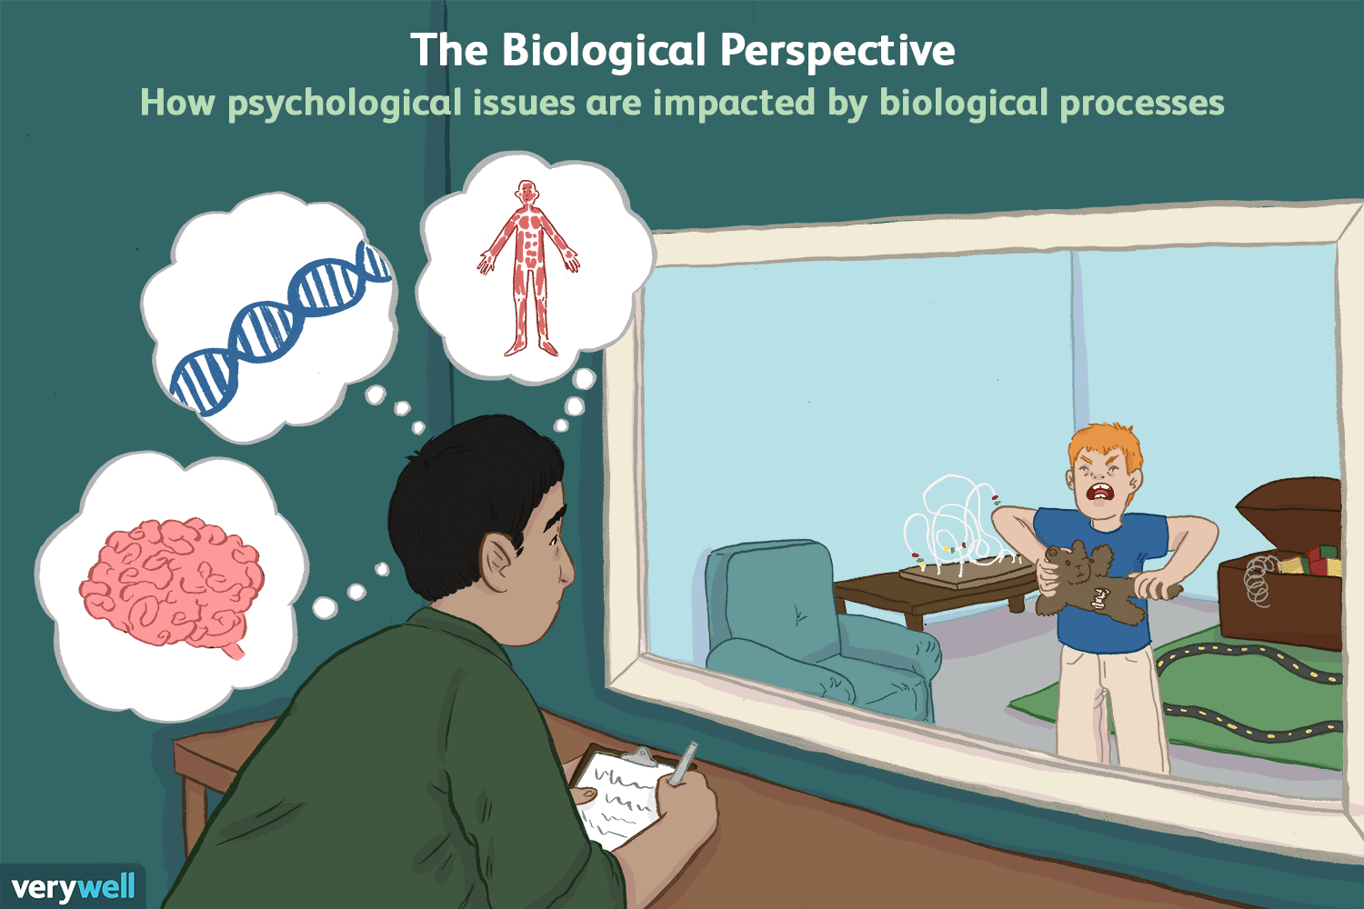

* **Aggression:**

Consider an issue like aggression. The psychoanalytic perspective might view aggression as the result of childhood experiences and unconscious urges. The behavioral perspective considers how the behavior was shaped by association, reinforcement, and punishment. A psychologist with a social perspective might look at the group dynamics and pressures that contribute to such behavior.

The biological viewpoint, on the other hand, would involve looking at the biological roots that lie behind aggressive behaviors. Someone who takes the biological perspective might consider how certain types of brain injury might lead to aggressive actions. Or they might consider genetic factors that can contribute to such displays of behavior.

## Main Topic Areas:

Biopsychologists study many of the same things that other psychologists do, but they are interested in looking at how biological forces shape human behaviors. Some topics that a psychologist might explore using this perspective include:

* Analyzing how trauma to the brain influences behaviors
* Assessing the differences and similarities in twins to determine which characteristics are tied to genetics and which are linked to environmental influences
* Exploring how genetic factors influence such things as aggression
* Investigating how degenerative brain diseases impact how people act
* Studying how genetics and brain damage are linked to mental disorders

This perspective has grown considerably in recent years as the technology used to study the brain and nervous system has grown increasingly advanced.

Today, scientists use tools such as PET and MRI scans to look at how brain development, drugs, disease, and brain damage impact behavior and cognitive functioning.

## Strengths and Weaknesses:

One of the strengths of using the biological perspective to analyze psychological problems is that the approach is usually very scientific. Researchers utilize rigorous empirical methods, and their results are often reliable and practical. Biological research has helped yield useful treatments for a variety of psychological disorders.

The weakness of this approach is that it often fails to account for other influences on behavior. Things such as emotions, social pressures, environmental factors, childhood experiences, and cultural variables can also play a role in the formation of psychological problems.

For that reason, it is important to remember that the biological approach is just one of the many different perspectives in psychology. By utilizing a variety of ways of looking a problem, researchers can come up with different solutions that can have helpful real-world applications.

**Example of Real Life about Biological Perspective:**

* **The fear response**:

The fear response gives way to fight, flight, or freeze behaviors. Which course of action an individual takes in the presence of a stressor relies on their biological make-up.

* **Mental illnesses:**

Understanding the biological processes of human behaviour has led to the development of psychoactive drugs which treat serious mental illnesses such as depression.

* **Brain Sleep:**

Dreams largely result from random brain activity during sleep and are therefore meaningless.

* **Evolutionary Function:**

The biological approach believes that most behavior is inherited and has an adaptive (or evolutionary) function.

**Example:**

 In the weeks immediately after the birth of a child, levels of testosterone in fathers drop by more than 30 percent. This has an evolutionary function.

**Biological Perspective on Development:**

The neuroscience/biological perspective **relates to the way that people act in terms of how they came to be**. With this perspective, genetics in the human body affect the way that they react to certain situations or the way that they act in different situations.

**Conclusion:**

The Biological Perspective is very important because it **provides clear understanding on the human body**. In particular, the effects of neurotransmitters, and behaviors of genetically related people.

By looking at the biological bases of human behavior, psychologists are better able to understand **how the brain and physiological processes might influence the way people think, act, and feel**.